|  |  |
| --- | --- |
| Epics Used | 3.3 |
| US Used |  |

Event-agenda

Functional requirements

Part 1

04.10.2016

Created by: Alekseikova Anastasiya

a.alekseikova@andersenlab.com

Andersen LLS

Content

[1. Structure 2](#_Toc463881378)

[2](#_Toc463881379)

[2. General 3](#_Toc463881380)

[2.1. Container 3](#_Toc463881381)

[2.2. Entry 3](#_Toc463881382)

[3. Event 4](#_Toc463881383)

[3.1. Name 4](#_Toc463881384)

[3.2. Dates 5](#_Toc463881385)

[4. Container 5](#_Toc463881386)

[4.1. Add Container 5](#_Toc463881387)

[4.2. Edit Container 6](#_Toc463881388)

[4.3. Delete Container 6](#_Toc463881389)

[4.4. Add Elements 7](#_Toc463881390)

[5. Types of the Agenda Elements 7](#_Toc463881391)

[5.1. Static agenda Elements 7](#_Toc463881392)

[5.1.1. 7](#_Toc463881393)

[5.1.1. Leadership Presentation (18563) 7](#_Toc463881394)

[5.1.2. Awards Panel (18563) 8](#_Toc463881395)

[6. Meeting allowed 9](#_Toc463881396)

[7. Event Groups 9](#_Toc463881397)

[7.1. The Element Form modal 9](#_Toc463881398)

[7.2. Groups in the Agenda page 10](#_Toc463881399)

**Event-Agenda view**

# Structure

* + In the main navigation menu the path is **Event->Event Name->Structure**
  + The URL:

**<http://alpha.skynet.managementevents.com/event/212/agenda>**

* The structure of the Agenda page

EVENT

Agenda

# 

Container1

Elements requiring table settings

Meetings Elements

Static Agenda Elements

Launch

1-2-1 meetings

Presentation/Keynote

Dinner

Presentation/Debate

Presentation/Chairman

Group Discussion

1-2-many placeholder

Presentation/Spotlight

Presentation/Panel Discussion

Headline

Awards Panel

Presentation/Case

Presentation/Cross-Function Keynote

Presentation/Fish Bowl

Presentation/Leadership Presentation

Presentation/SnapShot

# General (US3607)

The Agenda management is represented by two concepts: **Container** and **Element Entry**

## 2.1. Container

* Editable fields
  + Heading
  + Subheading
  + Start time
    - Date depends on the date tab selected in the UI
    - The starting date and time & ending date and time of the event set the limits to how the containers start and end time can be set --> The starting time of the container can't be earlier than the starting time of the event etc.
  + End time
* Settings
  + Visibility
  + The user can define whether these fields are displayed in the agenda
* Heading
* Subheading
* Start time
* End time

## 2.2. Entry

1. Entry types (in the initial version we need only the following types, others will be added later)
   * + Headline
2. Editable fields
   * + Entry subject
     + Start time
       - The user can't set a time that exceeds the start or end time of the container
     + End time
3. Settings
   * + Visibility
       - Entry subject
       - Start time
       - End time
     + Allow normal 1-to-1 meetings
       - Yes
       - No
     + Allow special 1-to-1 meetings
       - Yes
       - No
     + Allow 1-to-many meetings
       - Yes
       - No
     + Recommended time for meetings
       - Yes
       - No

# Event

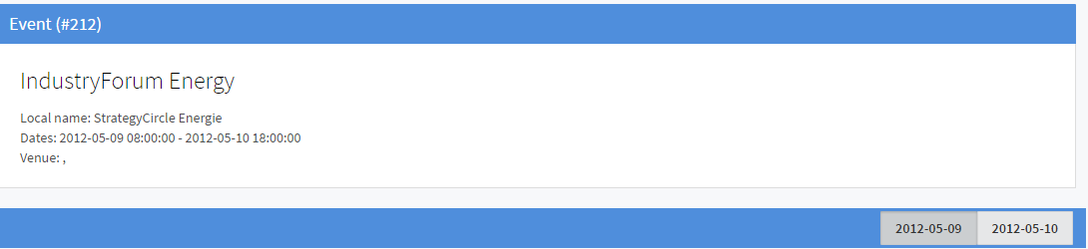

## 3.1. Name

* Every Event has the Type:

1. *Conference*
2. *IndustryForum*
3. *600Minutes*
4. *Summit*
5. *Kongressi*
6. *ManagementForum*
7. *Email approval*
8. *BusinessLounge*
9. *ExecutiveForum*
10. *IdeaGarden*
11. *StrategyForum*
12. *Growth Session*
13. *NeedSeeker*

* Every Event has the name (Energy) and the Local name (Strategy Circle Energy)
* ID

## 3.2. Dates

Days in the Agenda are creating automatically when the Event is created and are shown in the Agenda

* + - * + the date is equal 1 day (eg. 05.11.2016 08.00-18.00)
        + the system creates 1 day in the Event
        + the date is equal 2 days (eg. 05.11.2016 08.00 - 06.11.2016 22.00)
        + the system creates 2 days in the Event
        + the date is equal 2 days (eg. 05.11.2016 18.00 -06.11.2016 08.00)
        + the system creates 2 days in the Event
        + the dates are displayed on the each days in the Agenda view tabs

# Container

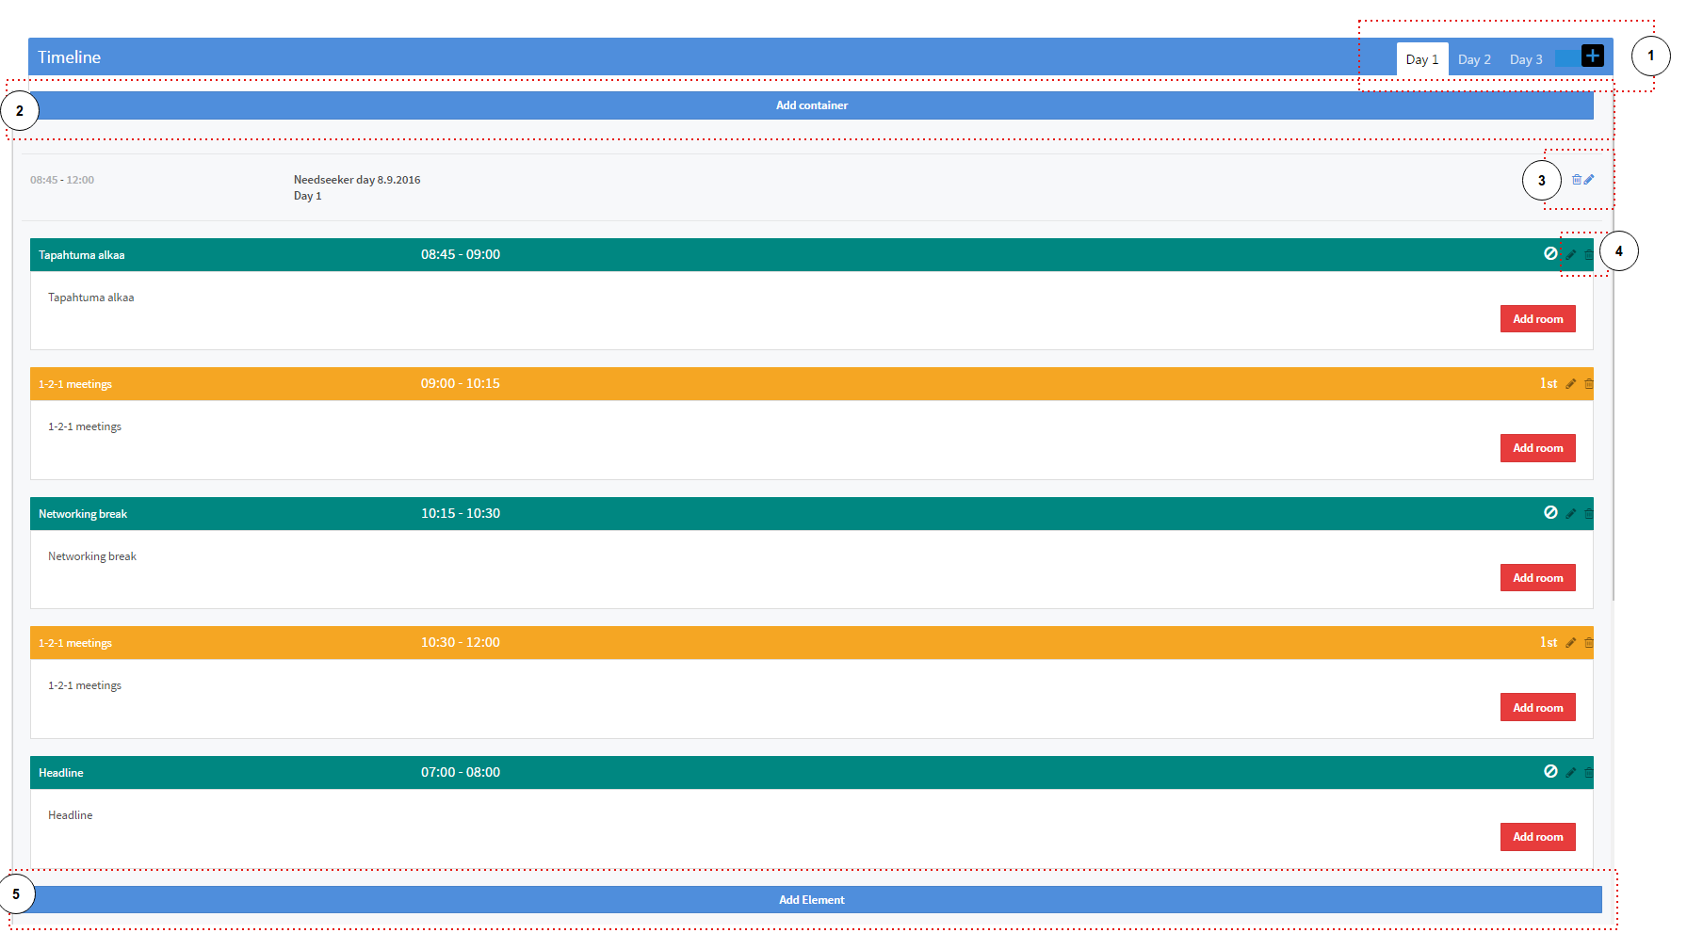

## 4.1. Editable fields

* + - * “Heading” – the name of the Container
* The names could be similar of each Containers
* The field is required
* The validation – only letters and numbers (is TBD)
* The name is displayed in the Container at the Agenda page
* “Sub heading” – the theme of the Container
* The themes could be similar of each Containers
* The validation – only letters and numbers (is TBD)
* The theme is displayed in the Container at the Agenda page
* “Start time” – the start time of the Container
* Date depends on the date tab selected in the UI
* The field is required
* The start time should be within the confines of the Event start time
* If the start time of the Container is less than the Event start time, the notification should appear
* The start time is displayed in the Container at the Agenda page
  + - End time

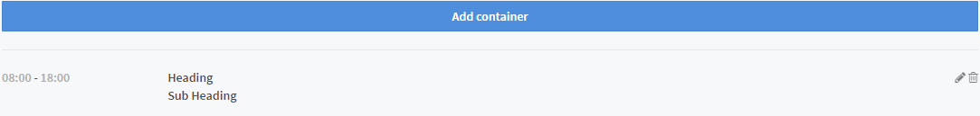

## 4.2. Add Container (US16906)

* The User can create as many Containers in the Agenda as he needs.
* Add Container -link
* Opens empty Container Form

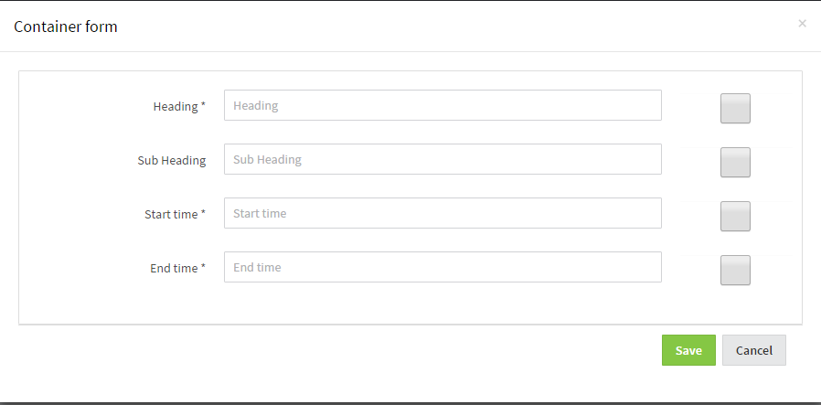

* When user adds Containers Event Agenda View:
  + New Containers added and existing containers need to be in chronological order, ordered by container's start time
  + If containers time are the same the containers should be presented side by side
* If user wan't to add new containers to other days, he needs to create new day or move to the Day x tab
* “Start time” – the start time of the Container
* The field is required
* The start time should be within the confines of the Event start time
* If the start time of the Container is less than the Event start time, the notification should appear
* The start time is displayed in the Container at the Agenda page
* “End time” – the end time of the Container
* The field is required
* The end time should be within the confines of the Event end time
* If the end time of the Container is more than the Event end time, the notification should appear
* The end time is displayed in the Container at the Agenda page

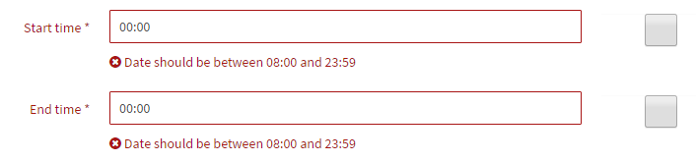

* “Check-boxes” – Inserted value is visible for app users, when check box is checked
* [Save] button – save the data
* [Cancel] button – cancel the data
* After clicking the button the modal is closed without saving the data
* The data is not displaying after reopening the modal
* [x] button – closes the modal without saving the data
* The data is not displaying after reopening the modal
* Clicking the page of the agenda– closes the modal without saving the data
* The data is not displaying after reopening the modal

## 4.2. Edit Container

**[Edit] button** allows user to edit event agenda's containers.

* This edit-pen opens Container Form Modal with editable fields
  + - All the previous values saved for this container is copied to fields

## 4.3. Delete Container

Delete Container icon remove the Container from the Agenda page

* After clicking the confirmation modal appears

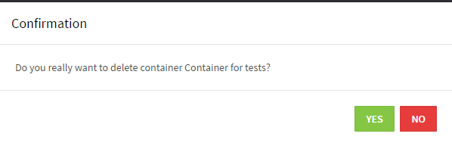

* Clicking [No] button closes the modal without deleting the Container
* Clicking [Yes] button If the Container has at list 1 element – the red alert “Error. Delete container failed” appears. Container is not deleted
* Clicking [Yes] button If the Container hasn’t elements – the green alert “Success. Container deleted” appears. Container is deleted

## 4.4. Add Elements (Elements Entry)

* Clicking [Add Element] button opens the Element Form modal
* Opens Element Form with Agenda Element Entry Type\* selection > Element Form with Agenda Element Type\* -selection
  + Element type forms for Event Agenda. Please see:
    - [#16018](https://meit.tpondemand.com/RestUI/Board.aspx?acid=6BC32917B18A3D8636A717CEE9D3CD07" \l "page=userstory/16018&appConfig=eyJhY2lkIjoiMzc3QTcyQTdGMTkwOTQ5OEVDOUNFOTUxMTM2RjA0MDkifQ==" \t "_blank) Support for adding new agenda elements to event agenda
    - [#14502](https://meit.tpondemand.com/RestUI/Board.aspx?acid=6BC32917B18A3D8636A717CEE9D3CD07" \l "page=userstory/14502&appConfig=eyJhY2lkIjoiMzc3QTcyQTdGMTkwOTQ5OEVDOUNFOTUxMTM2RjA0MDkifQ==" \t "_blank) Agenda elements - static agenda element management - UI
    - [#13662](https://meit.tpondemand.com/RestUI/Board.aspx?acid=6BC32917B18A3D8636A717CEE9D3CD07" \l "page=userstory/13662&appConfig=eyJhY2lkIjoiMzc3QTcyQTdGMTkwOTQ5OEVDOUNFOTUxMTM2RjA0MDkifQ==" \t "_blank) Agenda elements - add elements requiring table setting in Skynet (GD & lunch)
    - [#13678](https://meit.tpondemand.com/RestUI/Board.aspx?acid=6BC32917B18A3D8636A717CEE9D3CD07#page=userstory/13678&appConfig=eyJhY2lkIjoiMzc3QTcyQTdGMTkwOTQ5OEVDOUNFOTUxMTM2RjA0MDkifQ==) Agenda elements - meetings in Skynet
  + Because Element's day must be the same day than Container's and the time should be between Containers star and end time:
    - ​Default value in Element's Start time should be Container's starting date and time: YYYY-MM-DD HH:MM
    - And Ending time is Container's end date and time: YYYY-MM-DD HH:MM
    - These must be editable
* When user adds Element to Container in Edit Event Agenda View:
  + New Elements added and existing elements needs to be in chronological order, ordered by element's start times.
  + IF user inserts Start time and/or End time outside container's times (=out of range): present error message: "Can't add element outside containers time!"
  + If elements have same starting time, those elements are presented side by side

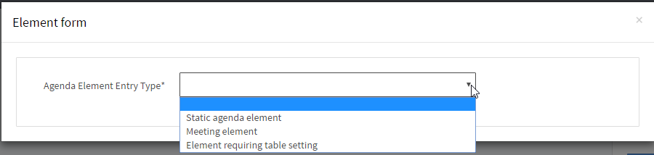

* Clicking [Add Element] button opens the Element Form modal
* Static agenda element
* Meeting agenda element
* Element requiring table settings
* After filling all the forms and clicking the [Save] button the Element appears in the Agenda page

# Meeting allowed

# Event Groups

## 7.1. The Element Form modal

In the modal the user should be able to **select multiple delegate groups for one agenda element.**

* The Group used check-box
  + Related to all element types
  + If its selected

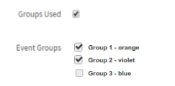

* + - Event's groups are presented below
  + If its not selected
    - The groups are not displayed



* The Event Groups field
  + The multiply chose is allowed
  + By default all boxes unchecked
  + User can select multiple groups to use one element
  + The element created is in no group section in agenda if no groups was selected after saving the data in the modal
  + The element created with groups section in agenda if several groups were selected after saving the data in the modal
* The amount of groups displayed in the modal is related to settings of the Event-Agenda

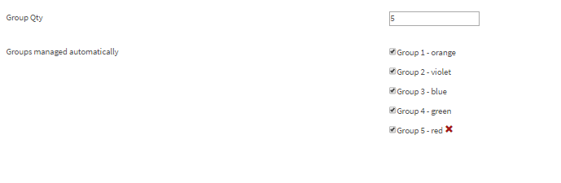

* + The path: Event->Event name->Settings
  + The URL: <http://alpha.skynet.managementevents.com/event/212/settings>
  + The default groups are created automatically depends on (is TBD)
  + The max groups quantity is not defined (is TBD)
  + There are exists only 5 colors related to each groups
    - Orange
    - Violet
    - Blue
    - Green
    - Red
  + The rest groups have only numbers
  + The groups are removed automatically if the user delete groups in Settings
  + The groups which have the elements couldn’t be deleted in the Settings

## Groups in the Agenda page

* Elements should be shown in a chronological order in the view based on the start time of each element
* Common agenda elements that are not using groups should be shown with "full view width"

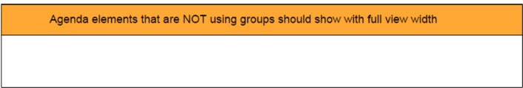

* Agenda elements which were created at the same time (hh:mm) will be separated by groups automatically:
  + Group 1
  + Group 2
  + Group 3 and so on

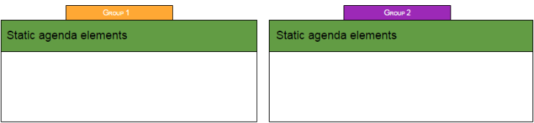

* The max quantity of the Groups
  + Is defined in the Settings
  + In case there will be more created at the same time elements then groups defined –
* The deleting of the groups
  + The User can’t delete the group with elements in the Settings page, then the alert appears
  + The removing while using the check-box in the Element modal –
* The editing of the groups
  + If the group of the element was changed into another –
  + If the group of the element was changed into no group –
* Another changes
  + If the time of the container was changed –
  + If the time of the element was changed –
  + If the type of the element was changed –
  + If the element was deleted –

|  |
| --- |
|  |
|  |
|  |
|  |
|  |
|  |
|  |
|  |